The Fifth Annual Children’s Spiritual Retreat

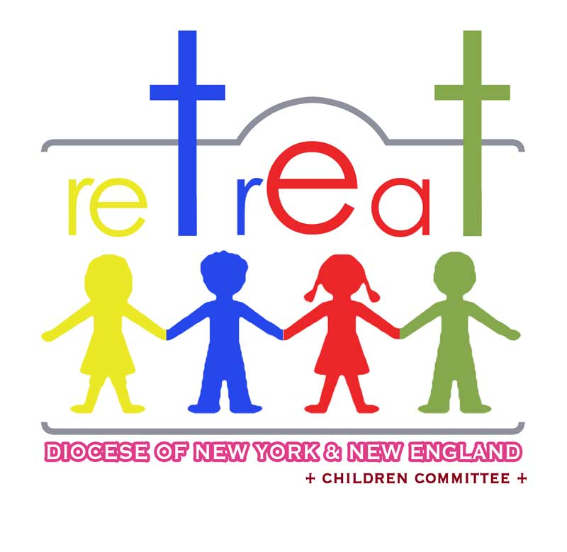
GRADE 3, 4 & 5

JUNE 12-14, 2015

Registration Form

Child's Name:
Date of Birth |  | / / |  |  | School Grade |  |  | T-Shirt Size

Father’s Name:

Address:
City |  |  |  | State |  |  |  |  | Zip
Home Phone: |  |  |  | Mobile Phone:
Emergency Contact |  |  |  |  | Emergency Phone

Church Name
City: |  |  |  |  | State:

Special condition, medications or allergies:

Enclosed is my full payment of: $_______

I ______________________ do agree for my child to join this Spiritual retreat and abide by its written rules.

Parent’s signature: ____________________________________

Church priest’s or Head of Sunday school's signature:

____________________________________________________

